财务部要求

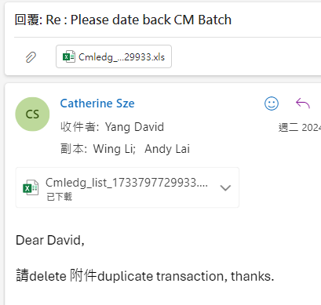

根据提供的Excel，以TranID为KEY进行删除。

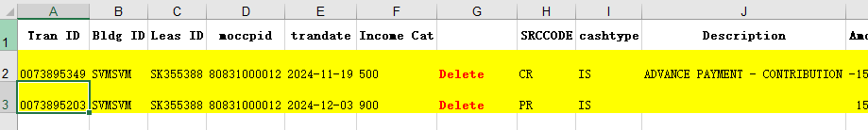

删除时候可能会有CMLEDGAPPLY关联，需要先删除关联数据

delete from cmledgapply where tranid = '0073895203'

delete from TB_CM_LEDGTOJRNL where tranid = '0073895203'

delete from cmledg where tranid = '0073895203'